NATIONAL AGRI-FOOD BIOTECHNOLOGY INSTITUTE (NABI)
(Dept. of Biotechnology, Ministry of Science & Technology, Govt. of India)
C-127, Industrial Area, Phase VIII, S.A.S. Nagar, Mohali-160 071.(Pb)
Website: www.nabi.res.in Tel: 0172-4604888; Telefax: 0172-4011916

TENDER FORM

TUBE-WELL AT NABI SITE, SECTOR-81, MOHALI

TO BE OPENED ON 26TH MAY, 2010 AT 03.30 PM AT NABI OFFICE

I N D E X

Sr.  No. | DESCRIPTION | PAGE  NO.
1. | Notice Inviting Tender (NIT) | 1
2. | Confirmation Certificate & Quotation Break-up Form | 2
3. | General Terms and Conditions of Tender | 3-6
4. | Tentative design specification and other Technical details with conditions | 7-11
5. | ANNEXURE-I | 12

NOTE: CONTRACTORS WHO HAVE DOWNLOADED THE TENDER DOCUMENTS FROM THE WEBSITE, ARE REQUIRED TO ATTACH DEMAND DRAFT/PAY ORDER FOR Rs.300/- (THREE HUNDRED ONLY) FAVOURING NATIONAL AGRI-FOOD BIOTECHNOLOGY INSTITUTE, MOHALI, BEING THE COST OF TENDER DOCUMENTS, FAILING WHICH THE TENDER WILL NOT BE CONSIDERED.
Details of Demand Draft/Pay order

- Demand Draft/Pay Order for Rs.300/- (Rupees three hundred only) drawn on ________________________________________________________________________
is enclosed with technical bid towards the cost of tender documents.

- Demand Draft/Pay Order for Rs.__________ (Rupees__________________________ ________________________________________) drawn on_______________________
_____________________________________________is enclosed with technical bid of the tender documents towards Earnest Money Deposit (EMD).

Signature of the Contractor___________________
Address__________________________________
Date______________ Rubber Stamp____________________________

Tender documents issued to:
M/s.__________________________________________
_____________________________________________
Signatures________________________
Date_____________________________

NATIONAL AGRI-FOOD BIOTECHNOLOGY INSTITUTE (NABI)
(Deptt. Of Biotechnology, Ministry of Science & Technology, Govt. of India)
C-127,Industrial Area, Phase VIII,S.A.S. Nagar, Mohali (Pb) PIN 160071
www.nabi.res.in Tele.+91-172-4604888 FAX: +91-172-4011916

NOTICE INVITING TENDER
(No.NIT/WORKS_TUBEWELL/1/2010)

Sealed tenders are invited on behalf of the Executive Director, National Agri-Food Biotechnology Institute, Mohali from the eligible Tubewell Contractors of C.P.W.D./P.W.D. and those of appropriate list of Department Central/State Govt. for the under mentioned work. Schedule of work and terms & conditions can be had from the office of the undersigned from 19th May’2010 till 26th May’2010 (upto 02.30 p.m.) OR download from the website ‘www.nabi.res.in’. Tenders shall be received latest by 26TH May’2010 (upto 03:00 p.m.) which shall be opened on the same day at 03.30 P.M. in the presence of the intending tenderers who wish to be present.

Name of Work : Boring, supply and installation of Tubewell in the compound of NABI, Sector-81, Mohali, having capacity of 1000-1200 ltr/pm having 300’ TDH and 1000’ – 1200’ bore depth.

Estimated Cost : Rs.20.00 lakh
Earnest Money : Rs.40,000/- (In the form of D.D. /F.D.R. in favour of NABI)
Cost of Documents : Rs.300/- (Terms & Conditions & Schedule)
Time of Completion : One month

The Executive Director, NABI, reserves the right to reject any/all quotations without assigning any reason or can award the work to more than one Tenderer.

ADMINISTRATIVE OFFICER

NATIONAL AGRI-FOOD BIOTECHNOLOGY INSTITUTE (NABI)
(Deptt. Of Biotechnology, Ministry of Science & Technology, Govt. of India)
C-127,Industrial Area, Phase VIII,S.A.S. Nagar, Mohali (Pb) PIN 160071
www.nabi.res.in Tele.+91-172-4604888 FAX: +91-172-4011916

NOTICE INVITING TENDER
(No.NIT/WORKS_TUBEWELL/1/2010)

CONFIRMATION CERTIFICATE & QUOTATION FORM

We, the undersigned, are experienced Tubewell suppliers and Erectors on turnkey basis. We have executed similar jobs meeting your requirement of minimum criteria as mentioned the General Terms & Conditions. We hereby submit our best rates as below for this job, for major items with specifications.

Sr.  No. | Item with Specification | Rate | Cost
1. | Motor, cable, Panel, Switches, etc.
2. | Pump, Valves, Gauges, etc.
3. | Pipe M.S.
4. | Stainers (SS)
5. | All fittings
6. | Gravel
7. | Drilling
8. | Installation of T.W.
9. | Development-commissioning & Trials
10. | Any other item

Signature_________________________
Name____________________________
Designation_______________________
Seal of the Company________________
Date_____________________________

NATIONAL AGRI-FOOD BIOTECHNOLOGY INSTITUTE (NABI)
(Deptt. Of Biotechnology, Ministry of Science & Technology, Govt. of India)
C-127,Industrial Area, Phase VIII,S.A.S. Nagar, Mohali (Pb) PIN 160071
www.nabi.res.in Tele.+91-172-4604888 FAX: +91-172-4011916

NOTICE INVITING TENDER
(No.NIT/WORKS_TUBEWELL/1/2010)

GENERAL TERMS AND CONDITIONS OF TENDER

- The Contractor may apply with proof of fulfilling the Registration conditions along with copies of Income Tax return, satisfactory work completion certificate and valid registration uner Works Contract Sales Tax/VAT of Govt. of Punjab.

- Estimated cost of the work is Rs.20.00 Lacs (Twenty lakh only) and the Tentative Technical details of supply and installation work are given at ANNEXURE-I.

- Time for carrying out the work will be 30 days and the commencement will be reckoned within five days of issue of award letter.

- Complete set of Tender contract documents to be compiled with by the tenderer whose tender may be accepted can be seen at the NABI’s website OR collect from the office of Administrative Officer, NABI, Mohali, address mentioned above; and the same can be downloaded from the website.

- The Tenders should be on the specified form (non-transferable) which may be obtained from the Administrative Officer, National Agri-Food Biotechnology Institute, Mohali, on payment of Rs.300/- in cash or by pay order payable to the National Agri-Food Biotechnology Institute, Mohali, between 11.00 AM to 04.00 PM on all working days.

NOTE: CONTRACTORS WHO HAVE DOWNLOADED THE TENDER DOCUMENTS FROM THE WEBSITE, ARE REQUIRED TO ATTACH DEMAND DRAFT/PAY ORDER FOR Rs.300/- (THREE HUNDRED ONLY) FAVOURING NATIONAL AGRI-FOOD BIOTECHNOLOGY INSTITUTE, MOHALI, BEING THE COST OF TENDER DOCUMENTS, FAILING WHICH THE TENDER WILL NOT BE CONSIDERED.

- Earnest money amounting to Rs.40,000/- (Forty thousand only), which should be in the form of Demand Draft or Banker’s Cheque of scheduled bank and drawn in favour of National Agri-Food Biotechnology Institute, Mohali, should accompany the tender. Tenders which are received without Earnest Money will be rejected.

- The completed tenders will be received in the office of Executive Director, National Agri-Food Biotechnology Research Institute, C-127,Industrial Area, Phase VIII,S.A.S. Nagar, Mohali, by registered/speed post or in person in double sealed cover super scribed with the name of work, date and time of opening written both on the inner and outer envelopes. The tenders will be received upto 2:30 P.M. on 26.05.2010 and will be opened at 3:30 P.M. on the same day in the presence of tenderer’s or their representative, present if any. Tenders received after the due date and time shall not be considered.

- Minimum criteria for award of contract: The Contractor should have successfully installed 05 similar Tubewells in the past 2-years.

- NABI does not bind itself to accept the lowest or any tender and reserves to himself the right of accepting the whole or any part of the tender and the tenderer shall be bound to perform the same at the rates quoted.

- Canvassing in connection with the tenders is prohibited and the tenders submitted by the contractor who resort to canvassing are liable for rejection.

- The tenderer shall not be permitted to tender for works in the concerned unit of NABI in which a relative is posted in the grade between Deputy Secretary and Junior Engineer (both inclusive). He shall also intimate the names of persons who are working with him in any capacity or subsequently employed by him and who are relatives as mentioned above.
(NOTE: A person shall be deemed to be relative or another if, and only if (a) they are members of a Hindu undivided family, or (b) they are husband and wife, or (c) the one is related to the other in the following manner, Father, Mother (including step mother), son (including step son), Son's wife, Daughter (including step daughter) Father's, Son's wife, Son's daughter, Sons' daughter husband, daughter's husband, daughter's son's wife, daughter's daughter's husband, Brother (including step brother), Brother's wife sister (including step sister), sister's husband).

- Tender submitted shall remain valid for 90 days from the date of opening for the purpose of acceptance and award of work, Validity beyond 90 days from the date of opening shall be by mutual consent.

- The tenderer shall quote rates both in figures and in words. He shall also workout the amount for each item of work and write in both in figures and in words. On checking if there are difference between the rates quoted by the tenderer in words and in figures or in the amount worked out by him, the following procedure shall be followed.

a. When there is a difference between the rates in figures and in words, the rates, which correspond to the amount worked out by the tenderer, shall be taken as correct.
b. When the amount of an item is not worked out by the tenderer or it does not correspond with rate written either in figures or in words, the rate quoted by the tenderer in words shall be taken as correct.
c. When the rate quoted by the tenderer in figures and in words tallies but the amount is not worked out correctly the rate quoted by the tenderer shall be taken as correct and not the amount.
- Tenderer will submit the breakup of total price as he would claim payments and get the same approved from NABI before taking Mobilisation advance.

- Before tendering, the tenderer shall inspect the site to fully acquaint himself about the conditions in regards to accessibility of site, nature and extent of ground, working conditions of site and locality including stacking of materials, installations of tools and plants (T&P) etc. conditions affecting accommodations and movement of labour etc. required for the satisfactory execution of the work contract No claim whatsoever on such account shall be entertained by the Employer in any circumstances.

- Earnest money will be forfeited if the contractor fails to commence the work as per letter of award.

- Except writing rates and amount, the tender should not write any conditions or make any changes, addition, alteration and modification in the printed form of tenders. Tenderers who are desirous to offer rebate the same should be brought out separately in the covering letter and submitted along with the tender.

- If it is found that the tender is not submitted in proper manner or contains too many corrections or absurd rates of item, it would be open for the department to take suitable action.

- Contractor must quote for all the items of the schedule/Supply and Erection, as listed in price break-up to be, otherwise their tenders are likely to be treated as incomplete.

- All material should be new and of reputed make, confirming to ISI standards wherever applicable.

- The latest ISI specifications shall be followed. If any discrepancy in regard to the standard of specification etc., item will be rejected.

- DEFECTS LIABILITY PERIOD: Twelve months from the date of completion as certified by the NABI.

- SECURITY DEPOSIT: A sum @ 10% of the gross amount of the bill shall be deducted from each running bill of the contractor till the sum along with the sum already deposited as Earnest Money, will amount to Security Deposit of 5% of the tendered value of the work. In addition, the contractor shall be required to deposit an amount equal to 5% of the tendered value of the contract as Performance security within the period prescribed for commencement of work in the Letter of Award issue to him.

- COMPENSATION: Contractor shall pay as compensation as amount equal to one percent of such smaller amount as the Employer (whose decision in writing shall be final) may decide on the cost of the whole work as shown in the agreement for every week that the work remains uncommented or unfinished or due quantity of work remains incomplete after the proper dates. Compensation to be paid shall not exceed 10% of the estimate cost of the work as shown in the agreement.

- Payment Terms: (1) 10% Advance against Bank Guarantee of the same amount;
(2) 65% pro-rata as per approved break-up against supply;
(3) 10% after erection of Tube well is completed;
(4) 15% after development, commissioning & successful trials – against furnishing of a Bank Guarantee of 5% of total contract cost as retention money to cover 1-year granted warrantee.

- Guarantee/Warrantee : All parts of the Tubewell shall be guaranteed for one year from the date of successful trials and handing over against any breakdown because of technical design failure or raw material defects of parts used. The contractor shall replace/repair the parts during guarantee/warrarantee period and will deposit 5% cost of the contract price as security for the same in the form of cash or Bank Guarantee covering the one year period.

- Executive Director, NABI, reserves the right to reject of accept any or all the tenders without assigning any reason thereof.

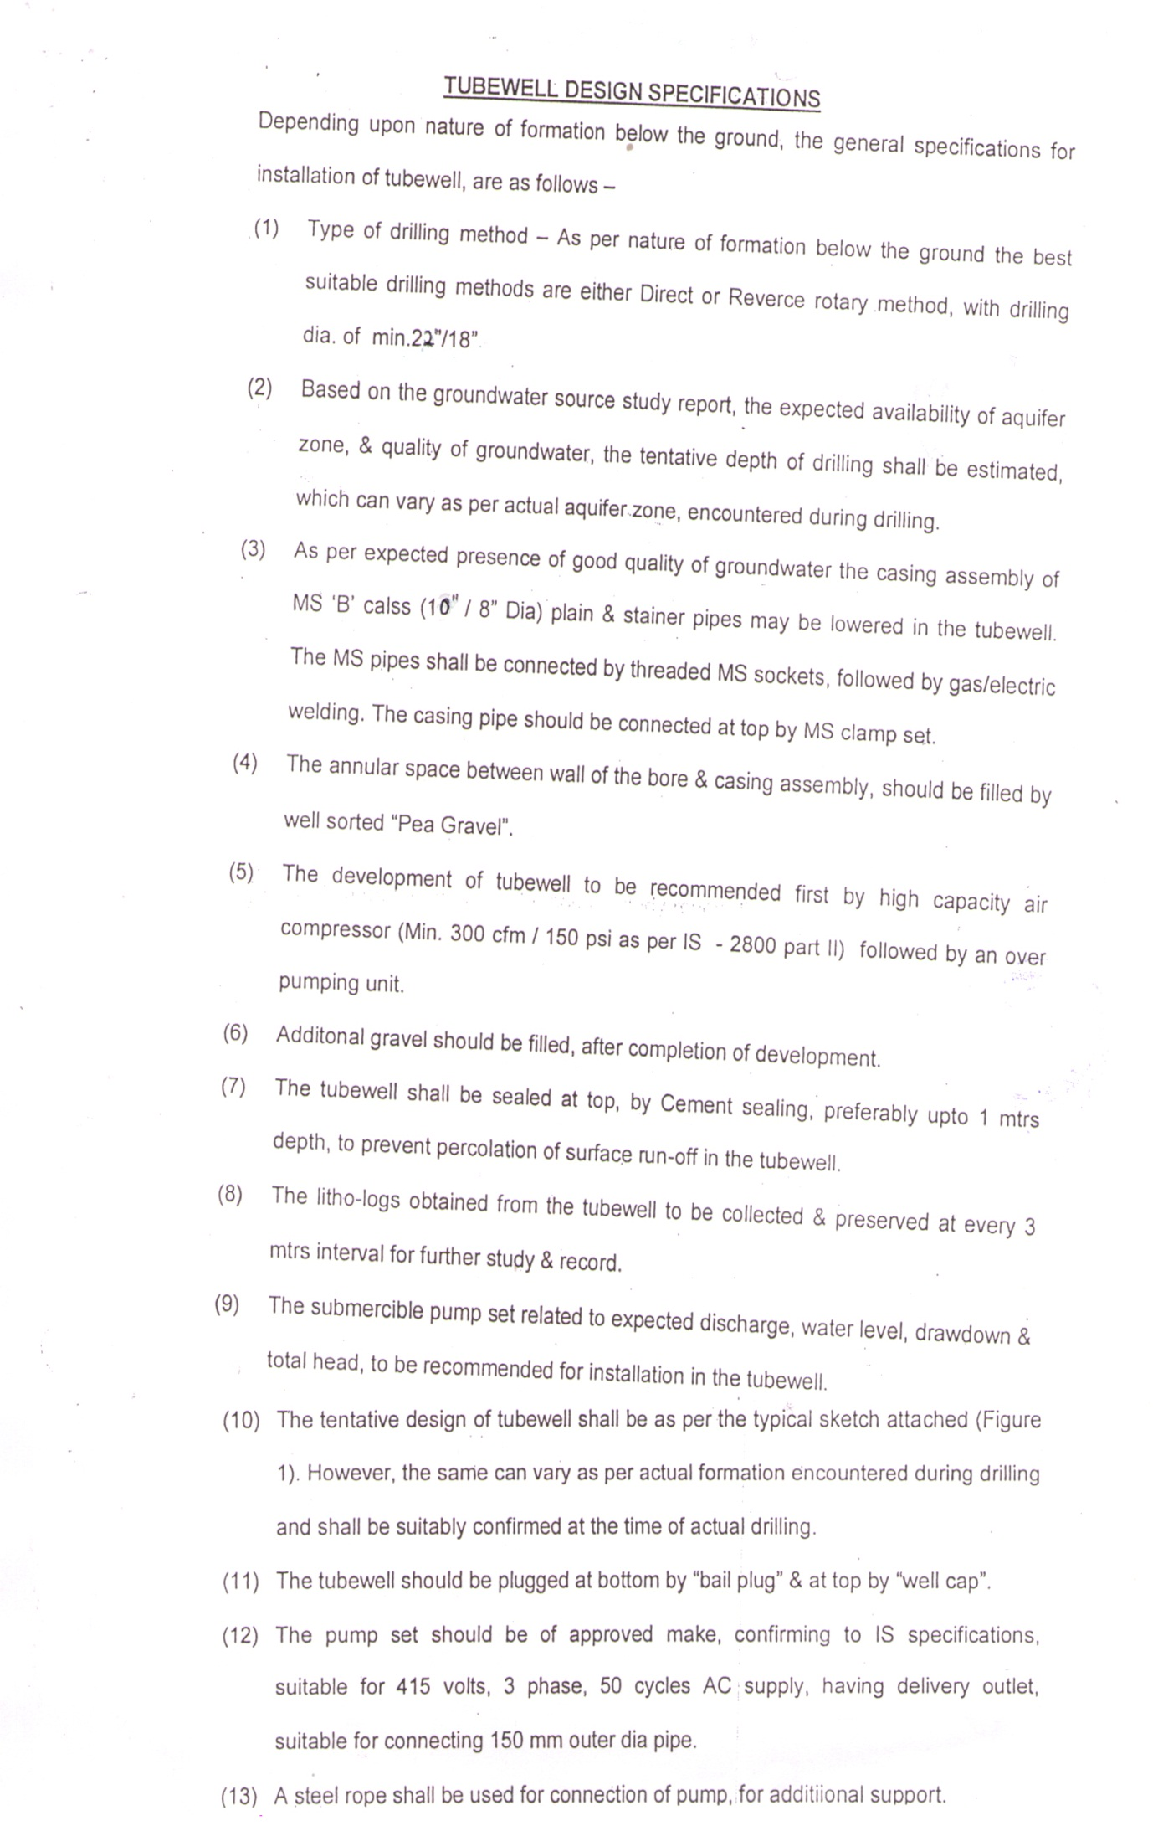

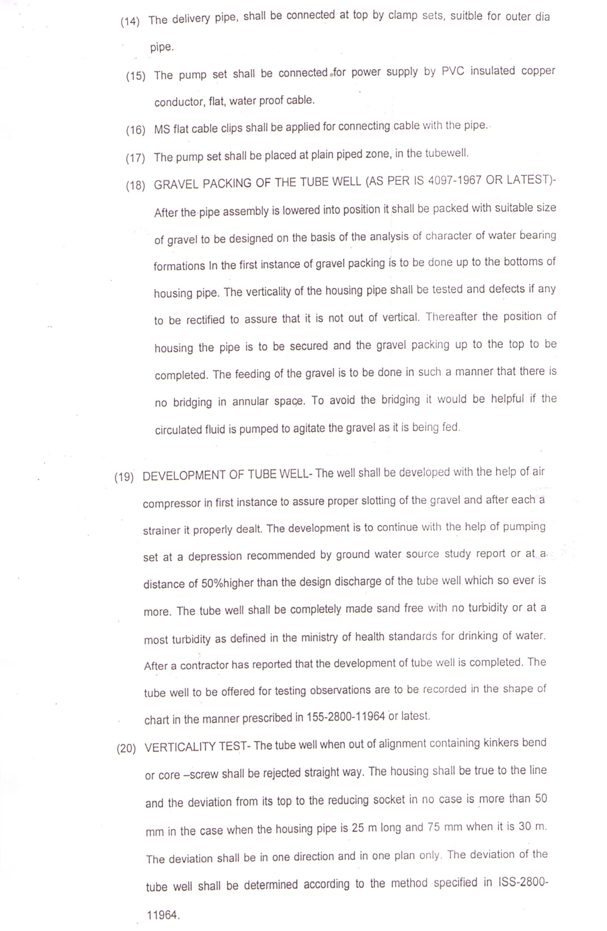

SCHEDULE OF REQUIREMENT:
- Name of the Owner : National Agri-Food Biotechnology Institute

- Address : Sector-81, SAS Nagar, Mohali, Punjab

- No. of Tube well and size : As indicated in the NIT

- Site : Probable site for the Tube well is to be identified by the Tenderer in consultation with the owner. The plan can be seen in the office of NABI.

- The Tube Well is to be installed for a minimum discharge of 1000 – 1200 ltr/per minute.

- The Tube well shall be equipped with the submersible pumping set turbine pump.

- The Tube well is installed for drinking water, irrigation, etc. in NABI Campus, Sector-81, Mohali.

- The water after development of well should completely sand free.

THE CONTRACT PERIOD

The contractor is required to furnish the following information:

- Recommendation on the suitability of site proposed by the NABI

- In case of difference in opinion; suggestion on other side nearby for the required design of the Tube well.

- Weather the test bore is proposed, and if yes, its diameter and depth.

- Likehood of increasing or decreasing depth indicated (b) above.

- Method of drilling.

- Size and types of different strainer or slotted pipe etc. if other than one specified are to be used.

- Probably yields of the water.

- Guarantee with regard to the vertically of the Tube well and sand contents in the discharge at the time handing over the well.

FINAL TEST
- The final test is to be conducted by the Contractor to clearly indicating the performance of the Tube well in regard to yield and the draw down.

- The proforma attached at ANNEXURE-I is to be completed by the driller after the Tube well has been completed.

LIST OF MAKE

Submersible Pump Make: KSB/MATHER & PLATT/KBL/WPIL/FLOWMORE/
FLOWSERVE

Pipes Make: JINDAL/TATA/SAIL/WELSPUN

Fitting Make: JINDAL SAW/KEJRIWAL CASTINGS/RATNAMANI METALS &
TUBES/ADVANCE STEEL TUBES/INDUS TUBES

ANNEXURE-I
Name of the Contractor:
Location of Tube Well:
__________________________________________________________________
STARATA CHART
Depth drilled
Size of bore
Housing Pipe
Blind Pipe
Stainless Steel Screen
Slot size
Gravel packing
Bail plug
Reducer
Housing Clamp
Centering guides
Well cap
Total hours developed
Static water level
Yield
Drawn Down
Pumping Water Level
Remarks, if any
Engineer-in-Charge

