NATIONAL AGRI-FOOD BIOTECHNOLOGY INSTITUTE
MOHALI



GENERAL CONDITIONS
OF CONTRACT
FOR
NABI, MOHALI

DEPARTMENT OF BIOTECHNOLOGY
(Govt. of India)

REQUEST FOR QUOTATION, NABI

Name of Work: PROVIDING & FIXING 12mm TOUGHENED GLASS PARTITION, DOOR ALONGWITH PATCH FITTINGS AT G.F, INTERIM FACILITY, NABI.
Completion Period: 2 weeks

Estimated Cost: Rs. 2, 17,853/-

Earnest Money: Rs. 4,357/- in favour of National Agri-Food Biotechnology Institute, Payable at Mohali
Last Date of submission of Quotation: 19/12/2013 up to 3.00 pm
Date of Opening of Quotation : 19/12/2013 at 3.30pm
In the office of Assistant Engineer (Civil), NABI

NOTICE INVITING QUOTATION/REQUEST FOR QUOTATION

1. Sealed quotations are invited on behalf of the Executive Director; NABI from agencies/contractors.

1.1 The work is estimated to cost Rs 2, 17,853/- (inclusive of all taxes etc).

- The time allowed for carrying out the work will be 15 days.

- The RFQ document consisting of location plan, specifications, the schedule of quantities of the work to be done and the set of terms and conditions of contract be complied with by the firm can be downloaded from the NABI’s website: - www.nabi.res.in.

- Quotations, which should always be placed in sealed single packet envelope along with specified EMD, with the, name of work and due date written on the envelope, will be received by the Assistant Engineer (Civil) up to 19th Dec 2013 at 3.00 PM. and will be opened by him or his authorized representative in his office on the same day at 03.30 PM.

- The bidder should submit EMD of Rs. 4,357/- in favour of National Agri-Food Biotechnology Institute payable at Mohali.

- The description is as follows:-

Bidders are advised to inspect and examine the site and its surroundings and satisfy themselves before submitting their quotations as to the nature of the ground and sub soil (so far as is practicable) the form and nature of the site, the means of access to the site, the accommodation they may require and in general shall themselves obtain all necessary information as to risks, contingencies and other circumstances which may influence or affect their quotation. A bidder shall be deemed to have full knowledge of the site whether he inspects it or not and no extra charges consequent on any misunderstanding or otherwise shall be allowed. The bidder shall be responsible for arranging and maintaining at his own costs all materials, tools and plants, water, electricity access, facilities for workers and all other services required for executing the work unless otherwise specifically provided for in the contract documents. Submission of quotation by a bidder implies that he has read this notice and all other contract documents and has made himself aware of the scope and specifications of the work to be done and of conditions and rates at which stores, tools and plant etc. will be issued to him by the Institute and any other local conditions and other factors having a bearing on the execution of the work.

- Executive Director, NABI does not bind him to accept the lowest or any other quotation and reserves to him the authority to reject any or all of the quotations received without the assignment of a reason. All quotations, in which any of the prescribed conditions are not fulfilled or any condition including that of conditional rebate is put forth by the bidder shall be summarily rejected.

- Canvassing whether directly or indirectly, in connection with quotations is strictly prohibited and the quotations submitted by the contractors who resort to canvassing will be liable to rejection.
- Executive Director, NABI reserves to himself the right of accepting the whole or any part of the quotation and the bidder shall be bound to perform the same at the rate quoted.

- The contractor shall not be permitted to quotation for works in the Institute if his near relative is an officer in any capacity (responsible for award and execution of contracts). He shall also intimate the names of persons who are working with him in any capacity or are subsequently employed by him and who are near relative to any Group A & B officer in the Institute. Any breach of this condition by the contractor would render him liable to be removed from the approved list of contractors of this Institute / debarring for further participation in the Institute for at least 5 years.

- The quotation for the works shall remain open for acceptance for a period of 90 days from the date of opening of quotations.

- No price preference to any corporate society/Registered society, Govt. Public Sector undertakings / bodies shall be given and quotations shall be exclusively dealt with on merit.

- The contractor shall comply with the provisions of the Apprentices Act 1961, minimum wages Act 1948, Workmen's compensation Act 1923, Contract Labour (Regulation and Abolition Act 1970), Payment of Wages Act 1938, Employer's Liability Act 1938, Maternity Benefits Act 1961 and the Industrial Disputes Act 1947 as applicable and the rules and regulations issued there under and by the local Administration / Authorities from time to time as well all provisions of law applicable to workmen. Failure to do so shall amount to breach of the contract and Competent Authority may at his discretion terminate the work. The Contractor/Firm shall also be liable for any pecuniary liability arising on account of violation by him of any of the said Acts and shall, indemnify the Institute on that account. Institute will not be liable for any act or omission on the part of the contractor in so far as any violation of any of the aforementioned acts.

- Each bidder shall submit only one quotation; either by him or as partners in a joint venture. A bidder who submits or participates in more than one quotation will be disqualified.

- The contractor/Firm shall be bound to complete the whole work as described in the schedule of items of works and the drawings, including additional items, if any, as per drawings and notifications. The issuance of certificate of completion as issued by Assistant Engineer (Civil) shall be mandatory and will be conclusive proof of completion of work.

- Interpretations, corrections and changes to the Quotations Documents shall be made by Addendum, if required.

- Each Bidder shall ascertain prior to submitting his Quotation that he has received all Addenda Issued and he shall so acknowledge their receipt in his Quotation.

- Following documents shall accompany the quotation:

- EMD of Rs. 4,357/- in favour of National Agri-Food Biotechnology Institute payable at Mohali.
- Duly signed/Stamped Request for Quotation document along with quoted rates in B.O.Q.

- The Provisions in the Quotation documents shall govern over the contents of the above paragraphs if in contradiction or variation.

Assistant Engineer (Civil)
NABI, Mohali
(On behalf of Executive Director, NABI)

LIST OF APPROVED MAKES
S.NO | DESCRIPTION OF ITEM | APPROVED MAKE
1. | 12mm toughened glass | Mico , Art n Glass, Gold Plus, Star Plus or equivalent as approved by Engineer-In-Charge
2. | Wall connecting profile | Dorma, Geze, Ozone
3. | SS Door Handles | Dorma, Geze, Ozone
4. | Connectors | Dorma, Geze, Ozone
5. | Top & Bottom Patch , Pivot | Dorma, Geze, Ozone
6. | Floor Spring | Dorma, Geze, Ozone
7. | Bottom Lock | Dorma, Geze, Ozone

Note:- Contractor to adhere to the above mentioned makes.

LAYOUT PLAN OF PROPOSED GLASS PARTITION

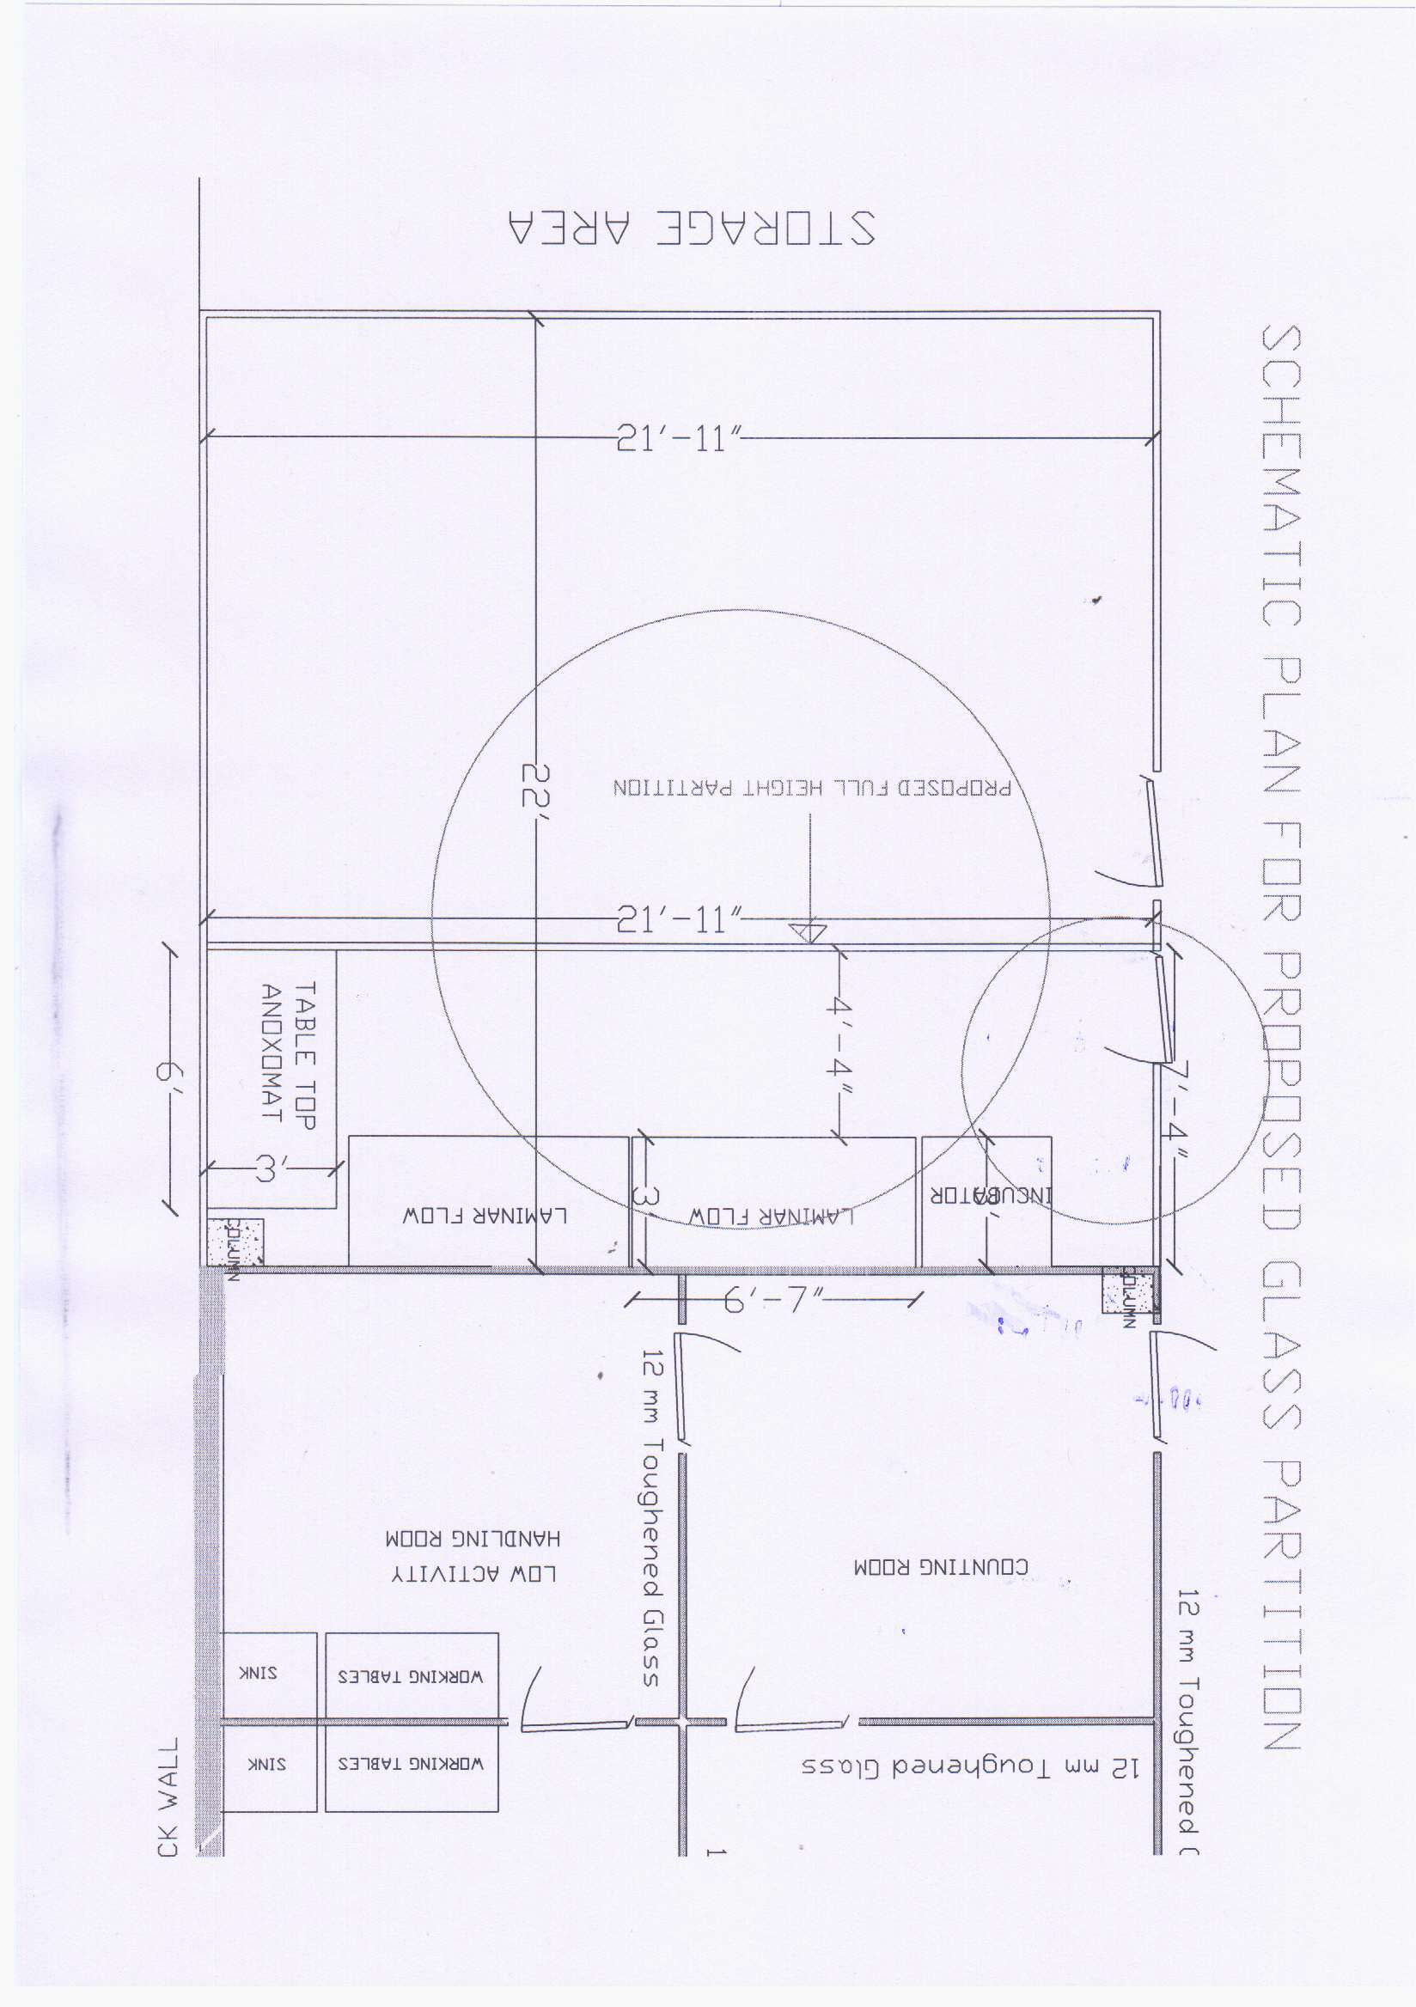
Terms & Conditions:-

- The Work shall be completed as per CPWD specification Vol-I & II.
- Rates quoted should be inclusive of all taxes, labour charges, Profit etc.
- Safety of workers/labour deployed shall be purely of the bidder.
- Bidders are advised to visit the site before quoting of bid.
- Conditional/Incomplete quotations shall be rejected.
- Statutory tax deductions, if any as per rules of Govt. shall be deducted.

Signatures of the Firm

